**Static vs Dynamic Website**

**What is Website?**   
Website is the collection of web pages, different multimedia content such as text, images, and videos which can be accessed by the URL which you can see in the address bar of the browser.

**Types of Website:**

* Static Website
* Dynamic Website

**Static Website:** In Static Websites, Web pages are returned by the server which are prebuilt source code files built using simple languages such as HTML, CSS, or JavaScript. There is no processing of content on the server (according to the user) in Static Websites. Web pages are returned by the server with no change therefore, static Websites are fast. There is no interaction with databases. Also, they are less costly as the host does not need to support server-side processing with different languages.

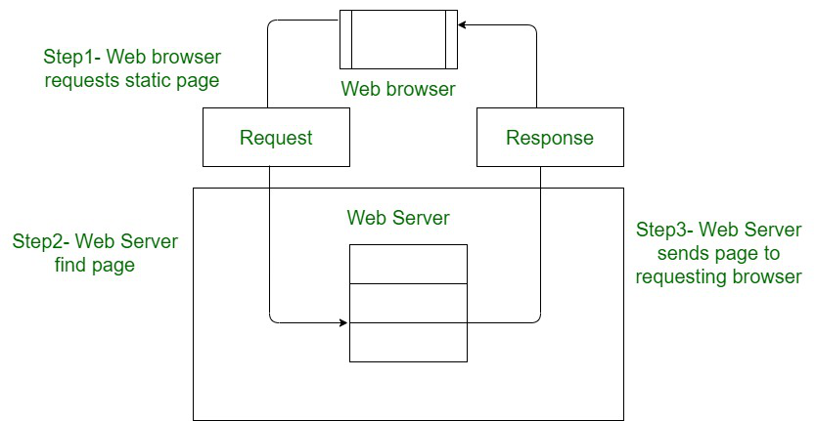

*Architecture of Static Website*

**Note:** Static does not mean that it will not respond to user actions, These Websites are called static because these cannot be manipulated on the server or interact with databases (which is the case in Dynamic Websites).

**Dynamic Website:** In Dynamic Websites, Web pages are returned by the server which are processed during runtime means they are not prebuilt web pages but they are built during runtime according to the user’s demand with the help of server-side scripting languages such as PHP, Node.js, ASP.NET and many more supported by the server. So, they are slower than static websites but updates and interaction with databases are possible.

Dynamic Websites are used over Static Websites as updates can be done very easily as compared to static websites (Where altering in every page is required) but in Dynamic Websites, it is possible to do a common change once and it will reflect in all the web pages. 

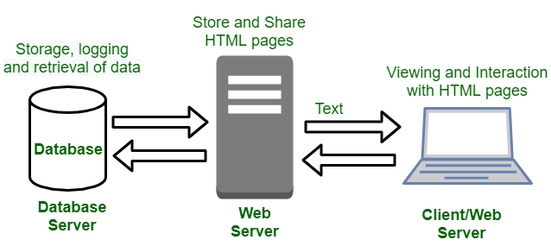

*Architecture of Dynamic Website*

**Difference Between Static and Dynamic Websites:**

| Static Website | Dynamic Website |
| --- | --- |
| Content of Web pages can not be change at runtime. | Content of Web pages can be changed. |
| No interaction with database possible. | Interaction with database is possible |
| It is faster to load as compared to dynamic website. | It is slower then static website. |
| Cheaper Development costs. | More Development costs. |
| No feature of Content Management. | Feature of Content Management System. |
| HTML, CSS, Javascript is used for developing the website. | Server side languages such as PHP, Node.js are used. |
| Same content is delivered everytime the page is loaded. | Content may change everytime the page is loaded. |